Mini Rube Goldberg
Name: _____________________________

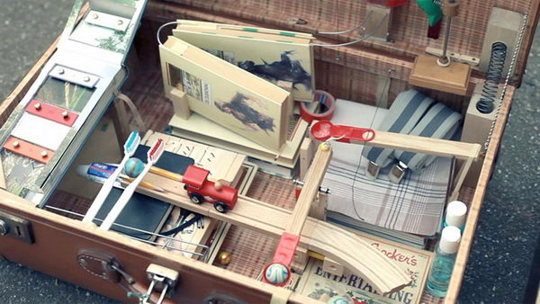

Goal:
Develop a Rube Goldberg Machine that utilizes at least 5 of the 6 simple machines. The six simple machines include levers, inclined planes, wheel & axle, screw, wedge, and pulley mechanisms. This is a very open-ended problem solving activity. Be creative and plan your steps before constructing your device. You must plan your steps and get instructor approval before beginning your project.

Parameters:
Fit inside a 30” x 30” x 30” imaginary area
Last a minimum of 30 seconds
Use 5/6 simple machines
No dangerous materials or projectiles
Final task to turn on a light

Hovercraft
Name: _____________________________

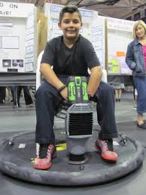

Goal:
Construct a hovercraft that can hover across the hallway floor for a minimum of 15 feet while supporting a student. The hovercraft may be powered by a shopvac or leaf blower provided by the school or student. A partner may push the hovercraft from the start line. Be mindful and use your resources when selecting materials, this project can be built for under $20.
Parameters:
No larger than 4 feet in diameter
Ability to properly secure a shopvac or leafblower
Ability to secure a chair or seat
Ability to setup and use within 5 minutes

Mousetrap Car
Name: _____________________________

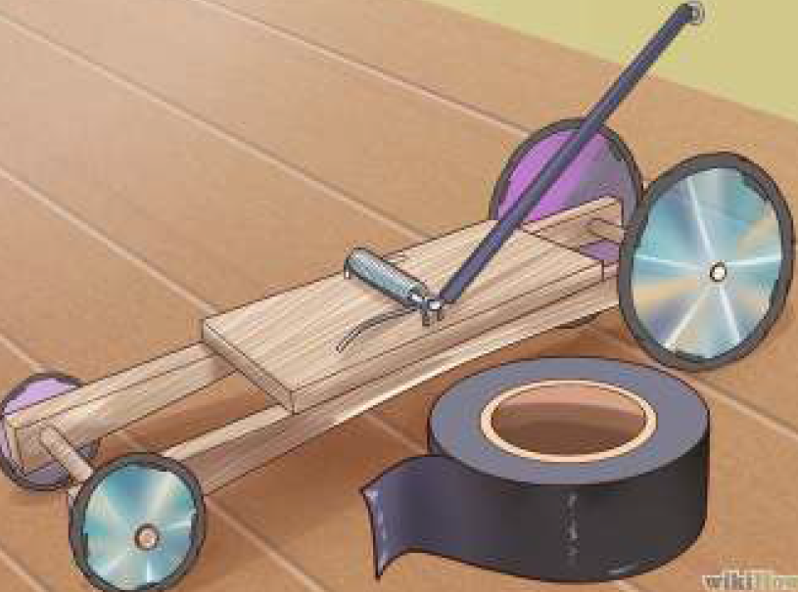

Goal:
Create a device that is able to travel down a 12 foot track, hit a small target, and catch a raw egg without causing damage to the egg. The target will placed 8” above the ground and the egg will fall from a height of 6 feet and 8” away from the wall. The track will be 3 feet wide. The device may be constructed from any material you wish. You may not touch the device except for triggering the mousetrap (no pushing, bumping, steering, etc.)

Parameters:
Use lightweight materials
May not touch device except when triggering the mousetrap
Egg cannot crack

Home TV Antenna
Name: _____________________________

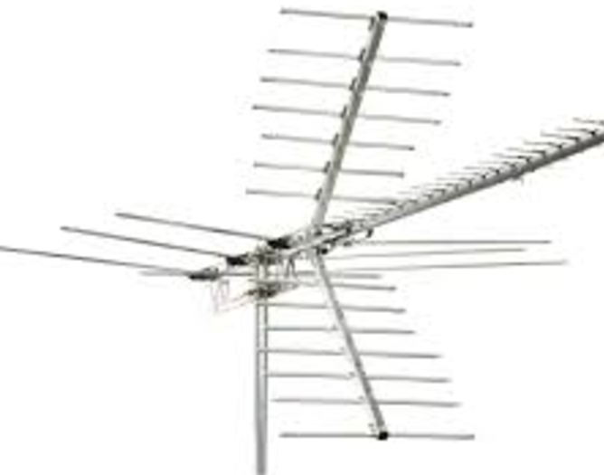

Goal:
Construct a TV antenna that is able to receive a clear signal from broadcast TV stations. The antenna will be tested using the TV in the drafting room. The antenna must be able to accept a standard coax cable cord for testing. Students will be allowed 5 minutes to set up the antenna before testing. The antenna may be constructed out of any material that you choose.

Parameters:
No larger than 2’x2’x2 in size
Not weigh more than 10 pounds

